**SOEN 6011 – Software Engineering Process**

**Function description – F1**

**Name: Surya Prakash Govindaraju (40085527)**

**Function**: arccos(x)

f(x)= arccos(x)

**Description**: The arccos function is the inverse of the cosine function. It returns the angle whose cosine is a given number. The angle returned by this function is measured in radians or in degrees. The inverse is also called as acos or cos-1.

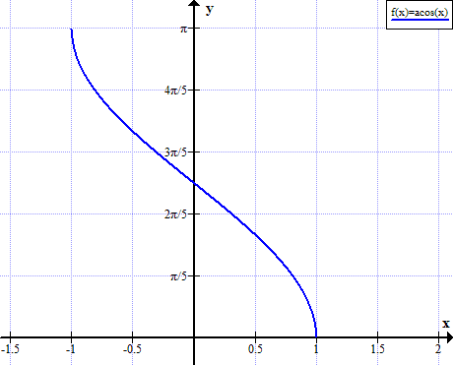

arccos function is useful when trying to determine the remaining two angles of a right triangle when the length of sides is known. It is calculated as below

Ɵ = arccos(adjacent/hypotenuse)

Derivative of arccos is given by,

$$\frac{d}{dx}arccos⁡(x)=\frac{-1}{\sqrt{1{-x}^{2}}}$$

**Domain**: −1 ≤x≤1

**Co-Domain**: 0≤y≤π or 0°≤y≤180°

**Characteristic**:

* Function is neither even nor odd
* Function is decreasing
* Ranges of the inverse function are subsets of the domain
* Function is defined for complex arguments
* Function is multivalued, unless its principal value is defined